E-commerce Site Flipkart

By

Vivek Kumar

(Software Engineer, Espire Infolabs, 2021)

Approved By:

**Table of Contents**

Abstract 4

1. Introduction 5

1.1 Goal 5

1.2 Need of the application 5

1.3 Existing system 6

1.4 Proposed system 6

1.4.1 Factors influencing consumer to shop online 6

1.5 Scope 7

1.5.1 Hardware Interfaces 7

1.5.2 Software Interfaces 8

2. Review of literature 8

3. System Requirement Analysis 9

3.1 Information Gathering 9

3.2 System Feasibility 9

3.2.1 Economic Feasibility 9

3.2.2 Technical Feasibility 9

3.3 Use Case Diagram 10

3.4 Class Diagram 11

3.5 Object Diagram 12

3.6 Sequence Diagram 13

3.7 Package Diagram 13

3.8 Deployment Diagram 14

4. Analysis of consumer behaviour online 14

5. Results, Data analysis and Discussions 15

Demography Factor: 16

5.1 Analysis and Interpretation 16

Behavioural factors: 19

Analysis and Interpretation: 19

Mode of awareness about Flipkart.com 20

6. Testing and implementation 21

6.1 Important Testing Cases 22

6.1.1 Updates 22

6.1.2 Traffic 23

6.1.3 Discount and Promo Code 23

6.1.4 Shopping Journey 23

6.1.5 Responsiveness Testing 23

6.1.6 Search Testing 23

6.1.7 Recommended Products 23

6.1.8 Payment Testing 24

6.1.9 Shopping Cart 24

6.1.10 Homepage 24

6.2: Testing Technique 24

6.2.1 Unit testing 24

6.2.2 Benefits 25

6.3: Integration testing 26

6.3.1 Purpose 26

7. Recommendations: 27

8. Conclusion 28

8.1 Limitations 29

8.2 Future Scope 29

9. References 29

# Abstract

Electronic Commerce is process of doing business through computer networks. A person sitting on his chair in front of a computer can access all the facilities of the Internet to buy or sell the products. Unlike traditional commerce that is carried out physically with effort of a person to go & get products, ecommerce has made it easier for human to reduce physical work and to save time. Security is the challenge facing e-commerce today & there is still a lot of advancement made in the field of security. The main advantage of e-commerce over traditional commerce is the user can browse online shops, compare prices and order merchandise sitting at home on their PC.

The main objective of the E-commerce Portal is to manage the details of Products, Customer, Shipping, Payment, and Category. It manages all the information about Products, Sales, Category, and Products. The project is totally built at administrative end and thus only the administrator is guaranteed the access. The purpose of the project is to build an application program to reduce the manual work for managing the Products, Customer, Sales, and Shipping. It tracks all the details about the Shipping, Payment, and Category.

# 1. Introduction

Flip kart houses everything you can possibly imagine, from trending electronics like laptops, tablets, smartphones, and mobile accessories to in-vogue fashion staples like shoes, clothing and lifestyle accessories; from modern furniture like sofa sets, dining tables, and wardrobes to appliances that make your life easy like washing machines, TVs, ACs, mixer grinder juicers and other time-saving appliances.

## 1.1 Goal

The main goal of e-commerce websites development is to sell products to users. The most successful websites are carefully optimized to achieve a high percentage of purchases. To achieve success e-commerce websites need to integrate all of the latest online closing & upsell techniques available which have been proven to increase the chances that a visitor will purchase.

There are many important elements that go into building a successful e-commerce website such as removing friction during the purchasing process, making the checkout smooth and easy, making the website fast and attractive, up selling users on related products, incentivizing buyers, reducing cart abandonment, nurturing past buyers to buy again, remarketing to past visitors who haven’t yet purchased, using the proper payment options, having a mobile ready design and many more things which are needed to develop and e-commerce website.

## 1.2 Need of the application

With the help of ecommerce web design you get an opportunity to have your products and services available to customers 24 hours. It gives a good exposure to your business and help you to reach out to potential customers. Since most of the people prefer to shop online due to paucity of time, you can easily make more revenue. With the help of an e-commerce website people can select and buy desired products anytime. They can pay easily through credit cards or other payment options available in website.

When it comes to buying gifts for your family and friends, an ecommerce shopping cart is what people prefer these days. Almost everything is available over internet. You just need to visit the website, select a product, and add it in your shopping cart and pay. The gift will be delivered to the mentioned destination on time. Is not that simple and hassle free?

Another feature of an e-commerce website is that you can save an item in your 'wish list' and buy it later.

## 1.3 Existing system

This existing system of buying goods has several disadvantages. It requires lots of time to travel to the particular shop to buy the goods. It is having lots of manual work. Since everyone is leading busy life now a days, time means a lot to everyone. Also there are expenses for travelling from house to shop. It is less user-friendly. In current system user must go to shop and order products. It is difficult to identify the required product. More over the shop from where we would like to buy something may not be open 24*7*365. Hence we have to adjust our time with the shopkeeper’s time or vendor’s time. In current e commerce system user have to go shop to view the description of the product. It is unable to generate different kinds of report.

## 1.4 Proposed system

The proposed system helps in building a website to buy, sell products or goods online using internet connection. Unlike traditional commerce that is carried out physically with effort of a person to go and get products, e- Commerce has made it easier for human to reduce physical work and to save time. The basic concept of the application is to allow the customer to shop virtually using the Internet and allow customers to buy the items and articles of their desire from the store. E-commerce is fast gaining ground as an accepted and used business paradigm.

### 1.4.1 Factors influencing consumer to shop online

Though there are several factors that influence consumers to shop online, but there are mainly four factors which influence consumer to shop online after reading literature in the field on consumer attitudes towards online shopping and these factors are discussed below in brief.

#### 1.4.1.1 Convenience

Convenience factor refers that it is easy to browse or search the information through online is easier than the traditional retail shopping. Through online, consumers can easily search product catalogue but if the consumer look generally for the same product or item in a traditional store manually it is difficult to visit physically and time consuming also. Convenience has always been a prime factor for consumers to shop online.

#### 1.4.1.2 Time saving

Time savings is one of most influencing factors of online shopping. Browse or search an online catalogue can save time and patience. People can save time and can reduce effort by shopping online. One possible explanation that online shopping saves time during the purchasing of goods and it can eliminate the traveling time required to go to the traditional store. On the other side, some respondent think that it is also time taken for delivery of goods or services over online shopping.

#### 1.4.1.3 Website design/features

Website design and online shopping activity is one of the vital influencing factors of online shopping. Website design features can be considered as a motivational factor that can create positive or negative feelings with a website. If website is designed with quality features it can guide the customers for successful transactions and attract the customers to revisit the website again.

#### 1.4.1.4 Security

Security is another dominant factor which affects consumers to shop online. However many internet users avoid online shopping because of credit card fraud, privacy factors, non-delivery risk, post purchase service and so on. But transaction security on the online shopping has received attention. Safe and secured transaction of money and credit card information increases trust and decreases transaction risk.

## 1.5 Scope

Online shopping is rising day by day in India. Because India is the country where computer users are increasing day by day so as the online shopping trends are also increasing. This project covers the online selling of cosmetics, fashion accessories, watches etc. The project shows the product category and then product details. From the product details, the product can be added to cart and can be bought.1.5 Platform Specifications – Deployment

### 1.5.1 Hardware Interfaces

Since the application must run over the internet, all the hardware shall require to connect internet will be hardware interface for the system. As for e.g. Modem, WAN – LAN, Ethernet Cross-Cable.

### 1.5.2 Software Interfaces

1. The flipkart e-store system shall communicate with the Configurator to identify all the available components to configure the product.

2. The flipkart e-store shall communicate with the content manager to get the product specifications, offerings and promotions.

3. The flipkart e-store system shall communicate with bill Pay system to identify available payment methods, validate the payments and process payment.

4. The flipkart e-store system shall communicate to credit management system for handling financing options.

5. The flipkart e-store system shall communicate with CRM system to provide support.

6. The flipkart e-store system shall communicate with Sales system for order management.

7. The flipkart e-store system shall communicate with shipping system for tracking orders and updating of shipping methods.

8. The flipkart e-store system shall communicate with external Tax system to calculate tax.

9. The flipkart e-store system shall communicate with export regulation system to validate export regulations.

10. The system shall be VeriSign like software which shall allow the users to complete secured transaction. This usually shall be the third party software system which is widely used for internet transaction.

# 2. Review of literature

Several researchers have carried out studies in their effort to examine consumer’s online buying behaviour. For example, Bellman et al (1999) investigated various predictors for whether an individual will purchase online. These authors concluded that demographic variables, such as income, education and age, have a modest impact on the decision of whether to buy online, whereas the most important determinant of online shopping was previous behaviour, such as earlier online purchases. This is consistent with Forrester Research which proved that demographic factors do not have such a high influence on technology as the consumers attitudes do (Modahl, 2000). Steinfield and Whitten (1999) suggested that the combination of the Internet, plus physical presence, provides more opportunities to capture business than the online-only presence, because they can provide better pre-purchase and post-sales services to lower consumer transaction cost and build trust in online stores.

# 3. System Requirement Analysis

## 3.1 Information Gathering

Users who know about the product should be able to find the product easily with the click of a button. Such users can search for the product by using the product name as the search term. Users who have to figure out the product that would satisfy their needs could use a search term to find a list of products and then should be able to filter the results based on various parameters like product type, manufacturer, price range, platform supported etc.

The users should be able to view the complete specification of the product and various images at different Zoom levels. The user should be able to read the customer reviews for the product and the ratings provided. They should be able to write their own reviews. They should be able to print out the specifications for a product or email the product page to a friend’s etc.

To increase the ease of use the user should be able to add a product to the shopping cart by dragging a product and dropping it in the shopping cart. A user should able to edit the contents of a shopping cart. They should be able to update the quantities of the products added to the cart and remove the products from the cart. The user should be able to remove the product from the shopping cart by dragging the product and dropping it outside the cart. The application can be made interactive by pop up messages when a product has been dropped in to the shopping cart or out of the shopping cart.

## 3.2 System Feasibility

The system feasibility can be divided into the following sections:

3.2.1 Economic Feasibility

The project is economically feasible as the only cost involved is having a computer with the minimum requirements mentioned earlier. For the users to access the application, the only cost involved will be in getting access to the Internet.

3.2.2 Technical Feasibility

To deploy the application, the only technical aspects needed are mentioned below:

Operating Environment Window 10

Platform Amazon Web Service

## 3.3 Use Case Diagram

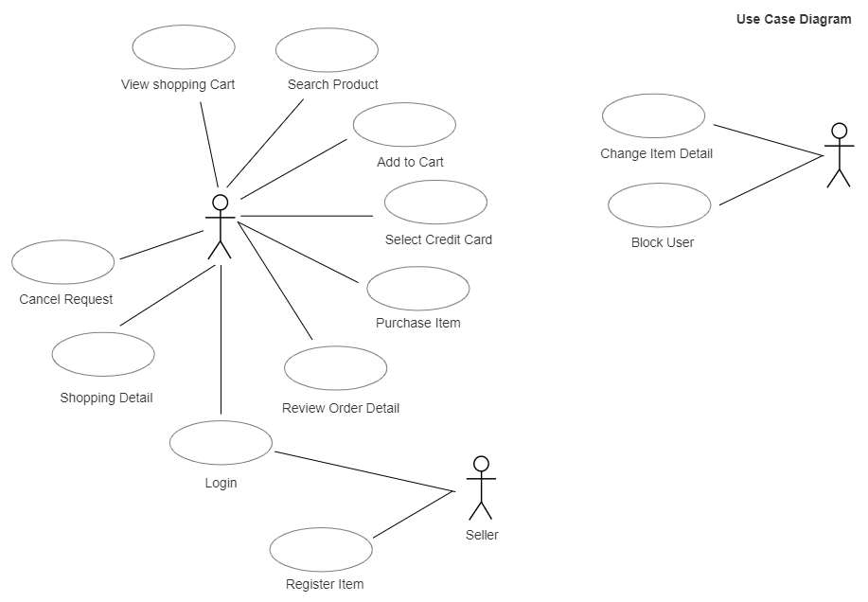

## 3.4 Class Diagram

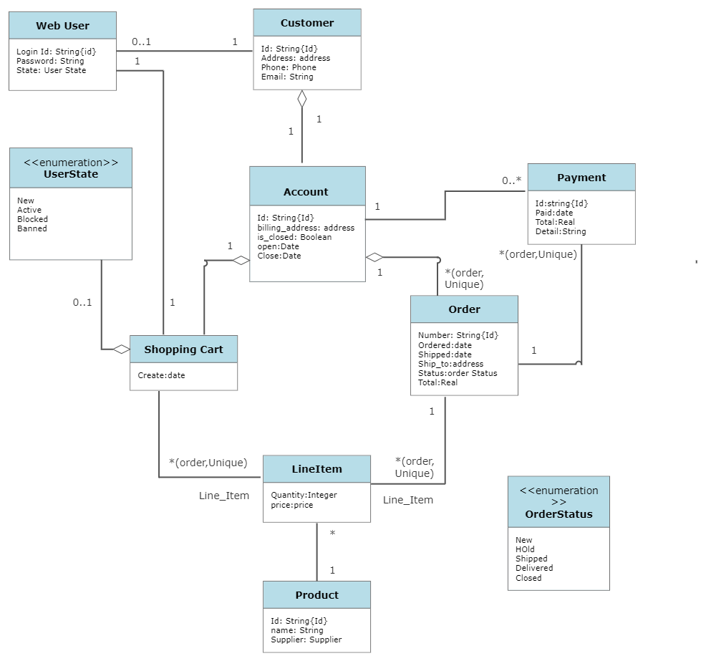

## 3.5 Object Diagram

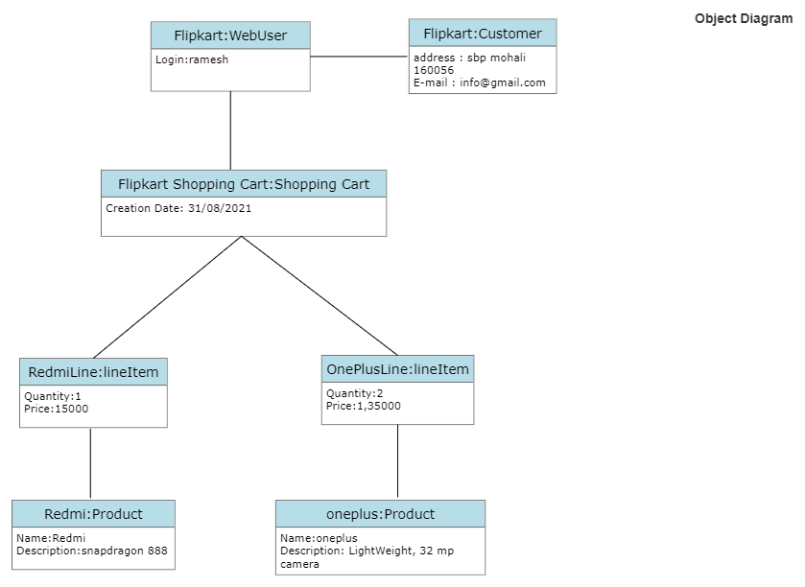

## 3.6 Sequence Diagram

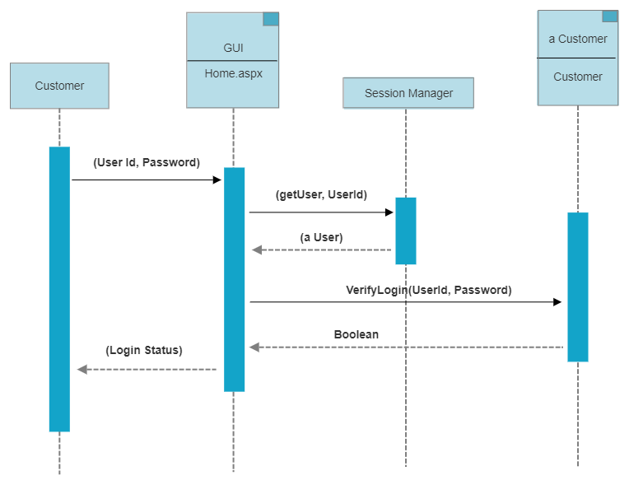

## 3.7 Package Diagram

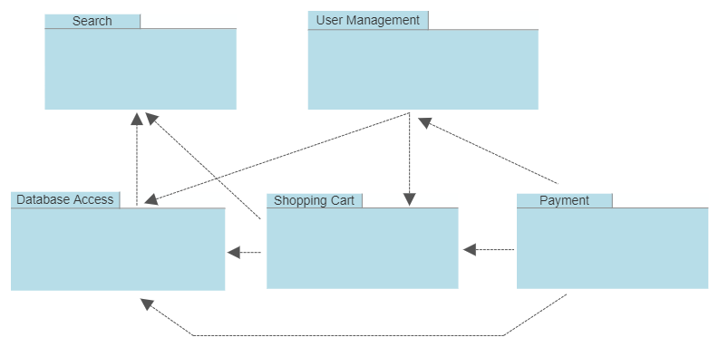

## 3.8 Deployment Diagram

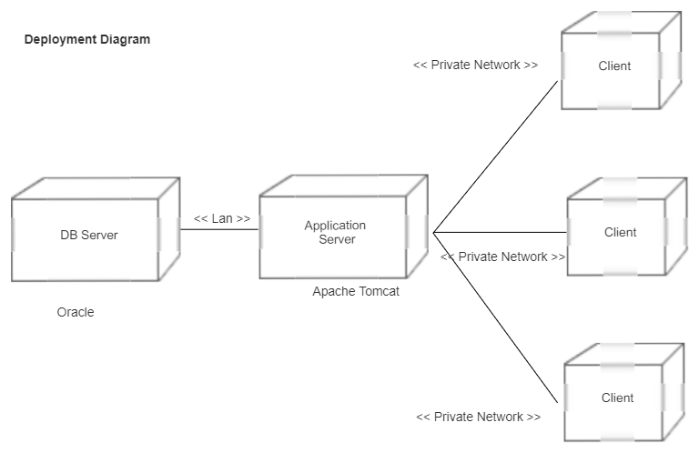

# 4. Analysis of consumer behaviour online

The report outlines about the most relevant behavioural characteristics of online consumers and examine the ways they find, compare and evaluate product information. Comparison of the newly collected survey data with the existing consumer behaviour theory resulted in detection of a number of issues related to a specific consumer group.

The purpose of this report is to translate these findings into a set of implementation activities on strategic and technological level. Execution of these recommendations will result in better conversion of visitors into customers and encourage customer loyalty and referrals.

The focus group of this study will be young adults aged between eighteen and thirty-four interested in buying a mobile phone or a related product.

Research by Shun & yunjie (2006) showed that there are product types, which are more likely to be sold online such as software, books, electronics and music. Reason for this is that when purchasing these types of products, one does not require personal inspection and most, if not all features, can be outlined in the product description and images. Most products in the mobile phone family belong to this category.

According to the recent research on consumer behaviour on the Internet users (Cotte, Chowdhury, Ratenshwar & Ricci, 2006), there are four distinct consumer groups with different intentions and motivations:

• Exploration

• Entertainment

• Shopping

• Information

Majority of young adults interviewed for purpose of this research tend to be active information seekers. A high level of technological confidence within this group tends to be an encouraging factor when it comes to product information research online. The following analysis presents both, focus group results and behavioural theory in a parallel fashion divided into two main research topics:

• Information Retrieval and Search Patterns

• Perception of Product Information Online

These two areas are mutually dependent and particularly important in a market where consumers have the power to choose the right product from a number of competing suppliers. Well-structured product information that cannot be found easily online is as much of a problem as is having easily accessible information that does not meet the consumer‘s expectations. The purpose of this report is to translate these findings into a set of implementation activities on strategic and technological level. Execution of these recommendations will result in better conversion of visitors into customers and encourage customer loyalty and referrals.

# 5. Results, Data analysis and Discussions

This chapter aims obtain the objective of the study by critically analysing the qualitative data through thoroughly examining the interviewee‘s responses and beliefs.

This has been achieved through evaluating the most relevant responses by the participants. The data has been analysed and discussed by comparing the comments made by the respondents with the literature review keeping in mind the research objective of the study. Thus, the rationale of this analysis is based on the personal answers provided by the respondents. An appropriately designed questionnaire was used to collect the primary data for the study. The data for 100 respondents was organized systematically in tables and graphs and then was subjected to analysis using appropriate statistical tools. The results of the analysis are presented in the following section in order to assess the customer perception towards online shopping on Flipkart.com in India. Here for analysing, we are considering two factors.

That is:

• Demographical factors

• Behavioural factors

## Demography Factor:

1. Gender of Respondents:

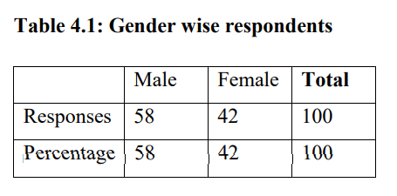

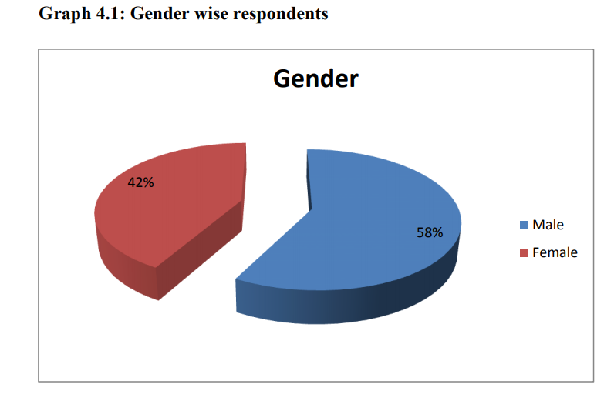

## 5.1 Analysis and Interpretation

According to demography profile, in this study 70 % male and 30% female respondents are part of my target population and they help me to fulfil my questionnaire from different area of Bangalore city. From these groups total respondents are 100. So, according to the survey result, the male respondents are more and can be told that they interested to shop online than female, even though both of them shop online.

2. Age Group:

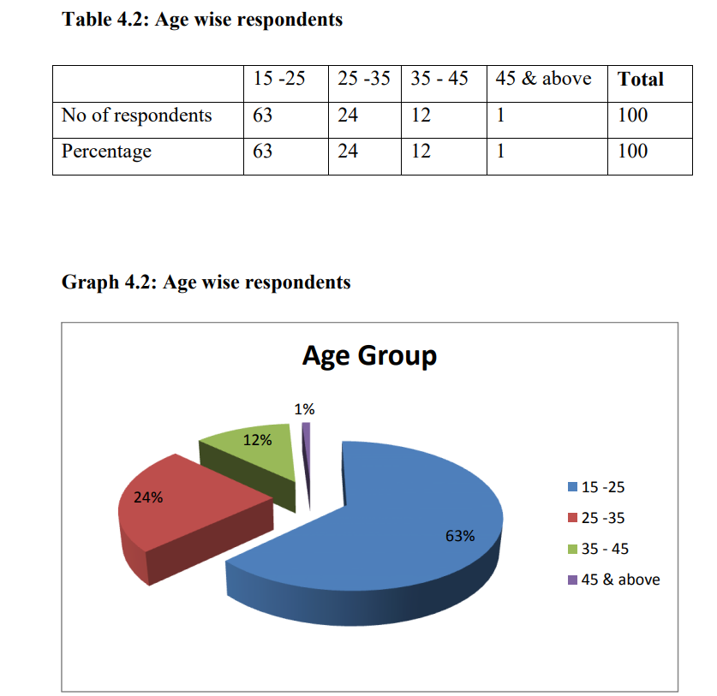

**Analysis and Interpretation:**

Below figure shows that 63% respondents are between 15-25 years old, 24% respondents are between 25-35 years old, 12% respondents between 35-45 years old, and 1% respondents are between 45&above. Overall result shows that between all of them the respondents who has age limit between 15 to 35 years (63%+24%= 87%) people are more familiar to shop online on my target population.

3. Occupation:

**Analysis and Interpretation:**

In this survey, 46% of the respondents are salaried and 39% are students. So they both together made majority of respondent‘s percentage (85%). 8% are business persons and 7% are House wife. Salaried persons and students will always look for new technologies and new services which make them more comfort.

4. Educational Qualification:

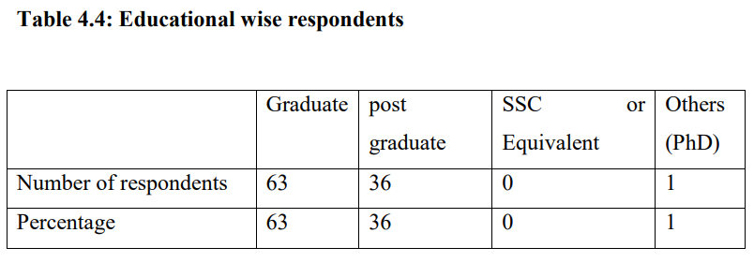

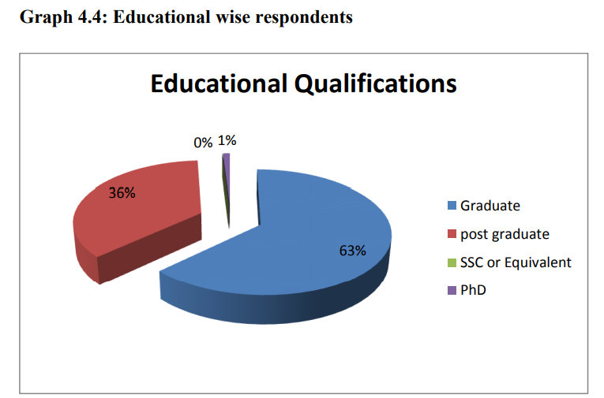

**Analysis and Interpretation:**

All of them in this survey are graduate and above qualified peoples only. Among these 63% are graduates, 36% are post graduates and one person is PhD.

5. Annual Income:

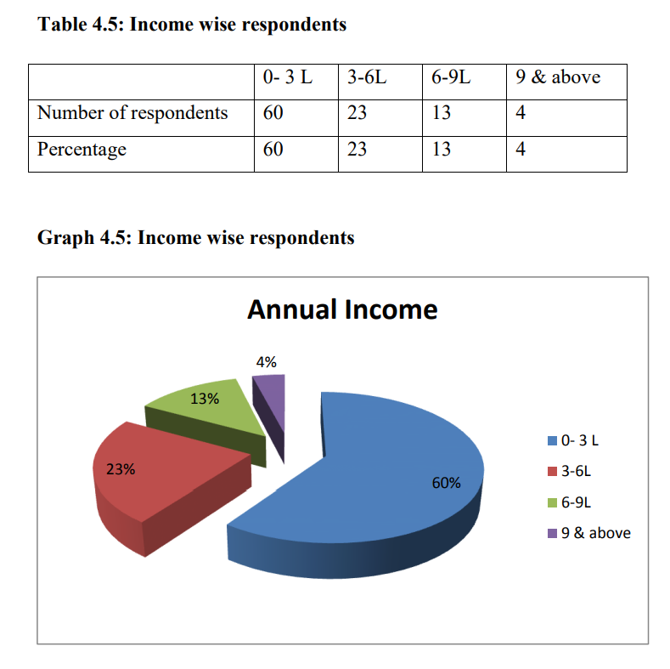

**Analysis and Interpretation:**

Since 39% of this survey is students most of them are of 0-3L income range, I.e. 60%. 23% of them are in 3-6L income range, 13% in 6-9L and 4% is 9 & above.

Behavioural factors:

This survey is conducted on those people who do online shopping and are aware of Flipkart. So everyone answered yes for those two questions.

6) Frequency of purchase from online:

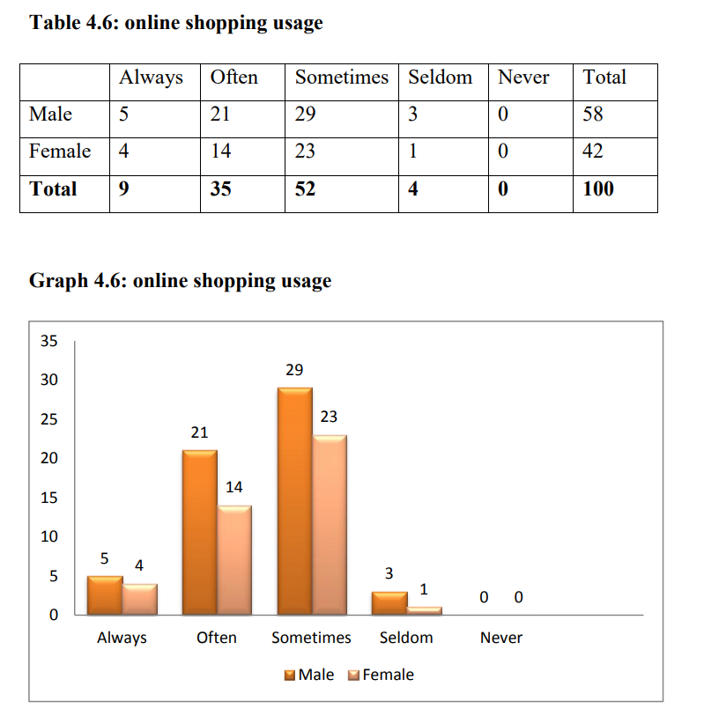

## Analysis and Interpretation:

More than half of them use online shopping sometimes, i.e. 52%. People who always and mostly shop through online shopping are also good in number, 9 and 35, together 44%. And who use online shopping rarely is very less in number 4%. Since only 44% are mostly using this, there is a wide space to fill and to make online shopping a great success. And there is not much gender difference in online shopping, which means both males and females enjoying online shopping and its benefits.

## Mode of awareness about Flipkart.com

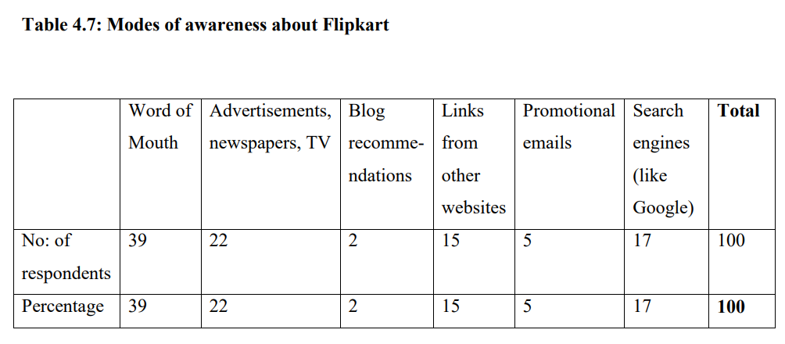

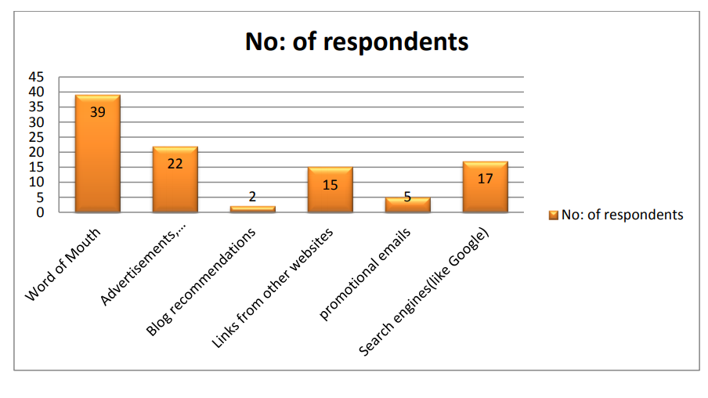

**Analysis and Interpretation:**

Most of them are aware about flip kart through word of mouth (39%) followed by television and online advertisements (22%). Customers got award through blog recommendations (2%) and promotional e-mails (5%) are very less in number. This means a good communication about Flip kart is going on through friends and families, which proves that word of mouth strategy by them is the most successful means of making people aware about their products. Success can only be gained through delighted customers who act as advocates for their products and there is a wide scope of other digital advertisement techniques like search engine marketing, email- marketing, providing links and blog recommendations in order to make more customers.

# 6. Testing and implementation

The term implementation has different meanings ranging from the conversation of a basic application to a complete replacement of a computer system. The procedures however, are virtually the same. Implementation includes all those activities that take place to convert from old system to new. The new system may be totally new replacing an existing manual or automated system or it may be major modification to an existing system. The method of implementation and time scale to be adopted is found out initially. Proper implementation is essential to provide a reliable system to meet organization requirement.

Some common testing types include:

| **Testing Type** | **What the Process Tests For** |
| --- | --- |
| Session Management | * Session storage – the amount of data stored in one session * Session expiration – how long it takes one session to expire |
| Page Display | * Checking for any runtime errors * Dead links or inappropriate font sizes * Dependency on poor plugins – which ones to remove and which ones to leave on? * Slow page downloads * Wrong page display |
| Browser Compatibility | * Incompatibility with certain browsers * Poor performance with specific browser extensions * Improper testing on major platforms like Windows, Mac OS X, and Linux |
| Analysing Content | * Checking for litigious or misleading content * Use of royalty-free images * Any copyright infringement * Personalizing elements * Checking for and removing out-of-date content |
| Usability | * Poor design * Lack of support * Navigable links on the website * Checking for link placements |
| Backup and Recovery | * Frequency of backups * Testing for backups by restoring them from time to time * Fault tolerance |
| Transactions | * Testing for financial transactions * Auditing and record-keeping |
| Processing Orders | * Checking functionality of shopping cart * Processing payments * Tracking orders * Recording of orders |
| Server Testing | * Checking for uptime * Stress testing the server * Running updates * Scalability analysis |
| Security | * Login credentials – make sure credentials are changed regularly * DDoS testing * Computer viruses * Ensuring data encryption |

# 6.1 Important Testing Cases

Using multiple test cases for ecommerce websites improves their performance and keeps the sites running smoothly.

## 6.1.1 Updates

Websites commonly receive updates from time to time, particularly when there are big events coming up. This is one of the most important test cases for an ecommerce website. You might want to opt for a new colour scheme, install a new theme, add a few new pages or even introduce some new banners.

But before you roll them out, test your website to ensure that they are working as you intend. All of these elements are designed to attract a customer’s attention, and you need to ensure they’re all presented properly.

## 6.1.2 Traffic

If you are gearing up for a big event like a sale, or busy business days like BFCM, prepare for an influx of traffic as well. Consider expanding your server size after checking your traffic data for the previous year. This will allow you to create a baseline for testing the load to determine how your platform holds up. It’s one of the most critical test cases for a shopping website.

## 6.1.3 Discount and Promo Code

Websites frequently offer discounts and promo codes during BFCM, and you probably will too. It’s crucial that you first test the promo codes or discounts and confirm whether they are being administered correctly.

## 6.1.4 Shopping Journey

Review and test your entire shopping journey from start to finish. Begin by adding products to your cart and go all the way to checkout so you can be sure the process is working properly. Your customer’s shopping journey should be as unperturbed as possible. There should be nothing hindering a customer making a purchase.

## 6.1.5 Responsiveness Testing

Customers will be using different devices and platforms to visit your website. Carry out responsiveness testing and ensure that your website loads up fast on all platforms. Test to ensure the products are visible on all platforms as well.

## 6.1.6 Search Testing

Most websites have a search bar so the average user can search for a particular product. The search feature is important for optimization purposes, so make sure that its working fine. When carrying out search testing, check whether different filter options are available, as well as parameters such as price, brand, and ratings.

## 6.1.7 Recommended Products

The “recommended products” tab is a key component of navigating through an ecommerce website. This shows recommended products based on a customer’s search history or previous keywords. Many website owners neglect this, but it’s highly significant if you want to maximize sales and keep customers on your site for a longer period of time. Checking if the right recommendations are showing up is a key part of ecommerce testing.

Check whether appropriate recommendations are given to the customers, as well as if recommendations appear on your website as soon as a customer has made the payment.

## 6.1.8 Payment Testing

This is perhaps one of the most critical test cases. If you are accepting payments online, ensure that the payments portal is working smoothly. If a customer repeatedly receives error notifications for unsuccessful or tailed transactions, they are simply going to order from somewhere else. It’s crucial for ecommerce website testing.

## 6.1.9 Shopping Cart

This is arguably the most important feature of your ecommerce websites. Here are some of the question your test needs to answer:

* Are all items being displayed in the shopping cart along with their totals?
* Are the taxes and additional charges being shown properly?
* Is the option to remove items visible?
* Is the option to add promo codes working properly?
* Is there an option to add more items to your cart?
* Does the cart update regularly?

## 6.1.10 Homepage

Last but definitely not the least is your home page. Your home page should load up quickly, with all the page elements intact. For instance, if there are any pop-ups, they need to show up quickly. Essential navigation features should be present on the home page too.

## 6.2: Testing Technique

### 6.2.1 Unit testing

In computer programming, unit testing is a software testing method by which individual units of source code, sets of one or more computer program modules together with associated control data, usage procedures, and operating procedures, are tested to determine whether they are fit for use. Intuitively, one can view a unit as the smallest testable part of an application. In procedural programming, a unit could be an entire module, but it is more commonly an individual function or procedure. In object-oriented programming, a unit is often an entire interface, such as a class, but could be an individual method. Unit tests are short code fragments created by programmers or occasionally by white box testers during the development process. It forms the basis for component testing. Ideally, each test case is independent from the others. Substitutes such as method stubs, mock objects, fakes, and test harnesses can be used to assist testing a module in isolation. Unit tests are typically written and run by software developers to ensure that code meets its design and behaves as intended.

### 6.2.2 Benefits

The goal of unit testing is to isolate each part of the program and show that the individual parts are correct. A unit test provides a strict, written contract that the piece of code must satisfy. As a result, it affords several benefits.

**1) Find problems early:**Unit testing finds problems early in the development cycle. In test-driven development (TDD), which is frequently used in both extreme programming and scrum, unit tests are created before the code itself is written. When the tests pass, that code is considered complete. The same unit tests are run against that function frequently as the larger code base is developed either as the code is changed or via an automated process with the build. If the unit tests fail, it is considered to be a bug either in the changed code or the tests themselves. The unit tests then allow the location of the fault or failure to be easily traced. Since the unit tests alert the development team of the problem before handing the code off to testers or clients, it is still early in the development process.

**2) Facilitates Change:**Unit testing allows the programmer to refactor code or upgrade system libraries at a later date, and make sure the module still works correctly (e.g., in regression testing). The procedure is to write test cases for all functions and methods so that whenever a change causes a fault, it can be quickly identified. Unit tests detect changes which may break a design contract.

**3) Simplifies Integration:**Unit testing may reduce uncertainty in the units themselves and can be used in a bottom-up testing style approach. By testing the parts of a program first and then testing the sum of its parts, integration testing becomes much easier.

**4) Documentation:**Unit testing provides a sort of living documentation of the system. Developers looking to learn what functionality is provided by a unit, and how to use it, can look at the unit tests to gain a basic understanding of the unit's interface (API).Unit test cases embody characteristics that are critical to the success of the unit. These characteristics can indicate appropriate/inappropriate use of a unit as well as negative behaviours that are to be trapped by the unit. A unit test case, in and of itself, documents these critical characteristics, although many software development environments do not rely solely upon code to document the product in development.

## 6.3: Integration testing

Integration testing (sometimes called integration and testing, abbreviated I&T) is the phase in software testing in which individual software modules are combined and tested as a group. It occurs after unit testing and before validation testing. Integration testing takes as its input modules that have been unit tested, groups them in larger aggregates, applies tests defined in an integration test plan to those aggregates, and delivers as its output the integrated system ready for system testing.

### 6.3.1 Purpose

The purpose of integration testing is to verify functional, performance, and reliability requirements placed on major design items. These "design items", i.e., assemblages (or groups of units), are exercised through their interfaces using black-box testing, success and error cases being simulated via appropriate parameter and data inputs. Simulated usage of shared data areas and inter-process communication is tested and individual subsystems are exercised through their input interface. Test cases are constructed to test whether all the components within assemblages interact correctly, for example across procedure calls or process activations, and this is done after testing individual modules, i.e., unit testing. The overall idea is a "building block" approach, in which verified assemblages are added to a verified base which is then used to support the integration testing of further assemblages. Software integration testing is performed according to the software development life cycle (SDLC) after module and functional tests. The cross-dependencies for software integration testing are: schedule for integration testing, strategy and selection of the tools used for integration, define the cyclomatical complexity of the software and software architecture, reusability of modules and life-cycle and versioning management. Some different types of integration testing are big-bang, top-down, and bottom-up, mixed (sandwich) and risky-hardest. Other Integration Patterns [2] are: collaboration integration, backbone integration, layer integration, client-server integration, distributed services integration and high-frequency integration.

#### 6.3.1.1 Big Bang

In the big-bang approach, most of the developed modules are coupled together to form a complete software system or major part of the system and then used for integration testing. This method is very effective for saving time in the integration testing process. However, if the test cases and their results are not recorded properly, the entire integration process will be more complicated and may prevent the testing team from achieving the goal of integration testing. A type of big-bang integration testing is called "usage model testing" which can be used in both software and hardware integration testing. The basis behind this type of integration testing is to run user-like workloads in integrated user-like environments. In doing the testing in this manner, the environment is proofed, while the individual components are proofed indirectly through their use. Usage Model testing takes an optimistic approach to testing, because it expects to have few problems with the individual components. The strategy relies heavily on the component developers to do the isolated unit testing for their product. The goal of the strategy is to avoid redoing the testing done by the developers, and instead flesh-out problems caused by the interaction of the components in the environment. For integration testing, Usage Model testing can be more efficient and provides better test coverage than traditional focused functional integration testing. To be more efficient and accurate, care must be used in defining the user-like workloads for creating realistic scenarios in exercising the environment. This gives confidence that the integrated environment will work as expected for the target customers.

#### 6.3.1.2 Top-down and Bottom-up

Bottom-up testing is an approach to integrated testing where the lowest level components are tested first, then used to facilitate the testing of higher level components. The process is repeated until the component at the top of the hierarchy is tested. All the bottom or low-level modules, procedures or functions are integrated and then tested. After the integration testing of lower level integrated modules, the next level of modules will be formed and can be used for integration testing. This approach is helpful only when all or most of the modules of the same development level are ready. This method also helps to determine the levels of software developed and makes it easier to report testing progress in the form of a percentage. Top-down testing is an approach to integrated testing where the top integrated modules are tested and the branch of the module is tested step by step until the end of the related module. Sandwich testing is an approach to combine top down testing with bottom up testing.

7. Recommendations:

• Flipkart has successfully placed itself into the prospects mind making it the India‘s largest online store with huge range of products. But it still needs to work on their core competence that is books and stationery items.

• Delivery services can be improved mainly in rural areas by selecting appropriate courier service which has services in customer area for dispatching an item.

• Can make free delivery to all priced products.

• Can include more coupon codes and gift vouchers for increasing the traffic of the customers. • Out of stock items can made available as soon as possible and intimate the needed customers. • Should look for International/ Overseas markets or Neighbouring Countries.

• Critical mass of Internet users – Internet users in India is increasing at increasing rate, so Flipkart can target more & more cities i.e. not only tier 1 & 2 but also tier 3 & 4 cities, which will help generate stronger customer base & more revenues.

• Should clearing focus on the Growing Online Apparel business & it can diversify into apparel category either organically or inorganically by acquiring other portals.

• User Experience: Portal should continuously aim to work to improve the user experience by adding more & more innovative features in the website like virtually shopping basket, virtual trial rooms. In this competitive world to differentiate via user experience, the ultimate winner will be the Indian online consumer.

• Should comprehensively invest into E-CRM & online reputation management.

• Logistics & Supply Chain: can continuously aim to reduce the delivery time cycle.

• Price will still be a factor as amazon being a huge company will use its economies of scale to remove their competitors from the market; therefore they need to be more competitive on that aspect.

# 8. Conclusion

In general, today’s businesses must always strive to create the next best thing that consumers will want because consumers continue to desire their products, services etc. to continuously be better, faster, and cheaper. In this world of new technology, businesses need to accommodate to the new types of consumer needs and trends because it will prove to be vital to their business’ success and survival. E-commerce is continuously progressing and is becoming more and more important to businesses as technology continues to advance and is something that should be taken advantage of and implemented.

## 8.1 Limitations

* Security - The biggest drawback of e-commerce is the issue of security
* Lack of privacy - Many websites do not have high encryption for secure online transaction or to protect online identity
* Tax issue
* Product suitability
* Cultural obstacles
* High Labour cost
* Legal issues

## 8.2 Future Scope

Information suggests the future of internet lies in mobiles. Experts say that 582 million people in India will use the Internet by 2019 and 70% of them will admittance the Web on mobile. This will reason to switch to app only model. Flipkart, Snapdeal, Amazon comes from users in small cities village and towns

In terms of future of e-commerce in the 21st century, experts predict the promising and glorious figures. In the foreseeable future, e-commerce will be confirmed as the major tool of sale for the goods and services. Successful e-commerce will become the notion which will be inseparable from the web because e-shopping is becoming more and more popular and natural. Thus, prevailing to future trends, e-commerce will have huge potential growth in sales and promotion.

Each year, there is a continuous growth in e-commerce deals. The volumes of sales for online store are much higher than the brick and mortars. To the present day, the internet sales boom the foundation for magnificent e-commerce future. To attract more customers, owners will not only have to increase the number of services available to them but also have to pay more attention to such elements like design, good presentation, etc.

# 9. References

1. <https://en.wikipedia.org/wiki/Amazon_(company)>
2. <https://www.smarthint.co/en/futuro-do-ecommerce/>
3. <https://www.robabdul.com/business/feasibility-study-cost-benefit-analysis-for-your-new-ecommerce-web-site/>